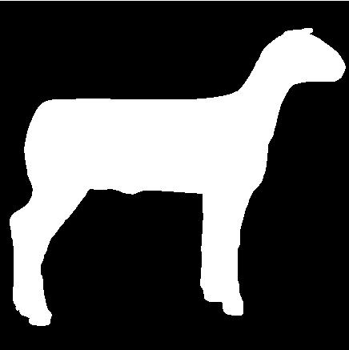

UNIVERSITY OF CALIFORNIA COOPERATIVE EXTENSION
SANTA BARBARA COUNTY
4-H
YOUTH DEVELOPMENT PROGRAM

SHEEP PROJECT LEVEL TESTS 1-5

Raising Sheep is an interesting and rewarding 4-H project. The 4-H Sheep Project Level Tests will help you learn what you need to know about your 4-H Sheep Project. This is a five step program for 4-H Sheep Project members. You can only complete one level per year. However during the 2013-14 & 2014-15 program years members may complete up to three levels.

Each level has minimum requirement that must be completed to earn that level award and they are listed on each level test. All skill and written tests require 80% success for passing. Project Level Test 1 is taken at club level. Project leaders will contact the Santa Barbara County 4-H Large Livestock Key Leader for the current test. Skill and written tests for Levels 2 & 3 will be available at County Events. See the county web site for dates and registration information.

Each Level requirement and testing resources can be found in current 4-H Curriculum. Level 1 test questions are found in Sheep Book 1”Rams, Lambs and You.” The Level 2 test resource is Sheep Book 2 “Sheer Delight.” And so on.

As you complete items required in a level, have your project leader sign the Level Requirement Sheet. Once all requirements are met submit your Level Sheet and the required certificates to the County Office. Level 1 pens will be awarded at club level. Level 2-5 will be awarded at the end of year County Awards.

